Lab 10 - Forms

- Write the HTML code to create a booking form for the Bistro web site (shown below) as follows:
  - Create a new web page called contact.html (copy the code from index.html and remove what is not needed)
  - Create a form which has the following form elements:
    - Date of reservation (input type=”date”)
    - Time of reservation (input type=”time”)
    - Query on flexibility using radio buttons (input type = “radio”)
    - Number of guests (input type=”number”)
    - Open ended query element – (use <textarea>)
    - Name of guest making reservation (input type=”text)
    - Phone number of guest making reservation (input type=”text)
    - Submit & Reset buttons
  - Style the form using CSS to make it more pleasing to the eye.
  - Ensure that the form is responsive.

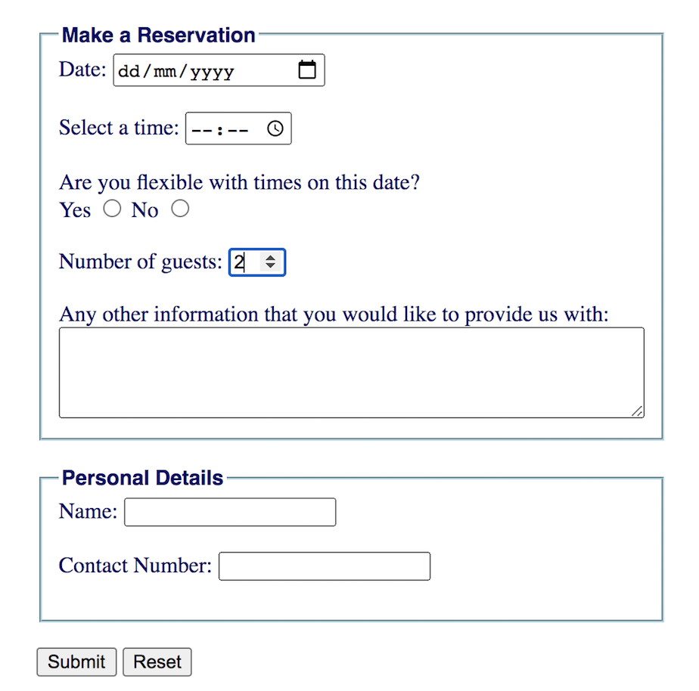

The solution will be up after lab on Thursday.

